LETTER OF ATTESTATION

To:- Whom it may concern.

I, the undersigned on behalf of the above committee for the fundraising event:- Irelandwest-truckshow wish to attest to the following facts.

Name of Driver: ______________________
Truck Reg No; ______________________
Employed by ______________________ ______________________ ____________________

Did attend and take part in the event on Sunday 10th September 2023 from the hours of _________ to ________ during my time off and rest time, as an unpaid and personal event. ( Record time leaving home and time returned back home )

Drivers signature: ______________________________________

Committee Member Signature 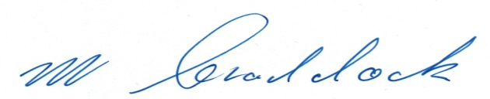 ( Michael Craddock )

IRELANDWEST-TRUCKSHOW. COM C/O -Michael Craddock, Dalgan Rd, Shrule, Galway. 00353 87 2654865 E Mail:- shrule22@gmail.com

