.
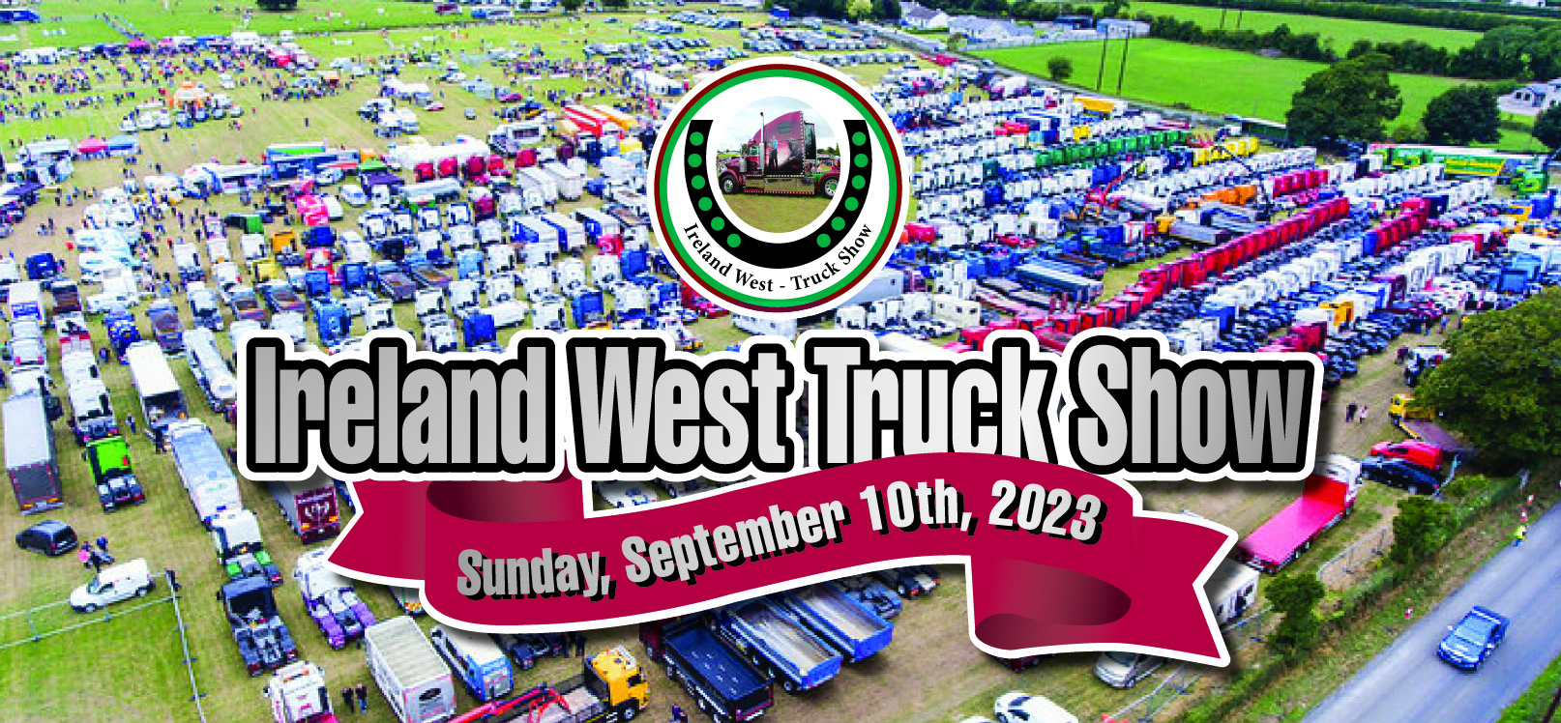
( Thanks to Tipperary Truck show for use of the back ground photo )
10th September at Glencorrib, Shrule, Co Mayo
Best:- Scania, Volvo, Merc, Renault, Hine, Iveco, Man, Daf, Rigid, Fleet, best small commercial & Truck of the show,
Entry fee:- € 30.00 per truck / fleet of 3 or more € 80.00
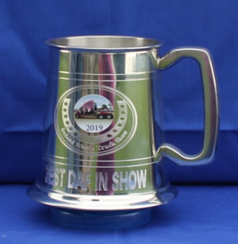
Winning tankard
Free:- Meal voucher & show plaque to all drivers who register
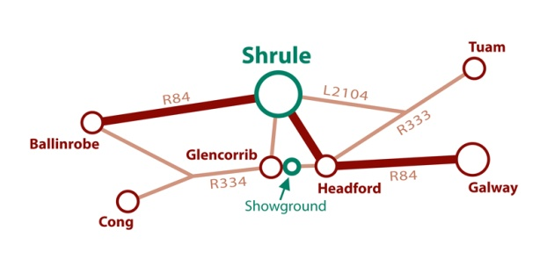
For more information visit :- www.irelandwest-truckshow.com
Face book:- michael craddock ( irelandwest-truckshow )
Mobile 087 2654865

The truck show field is adjacent to Shrule Vintage show. Drivers & their family will have free entry to the vintage show.
Drivers can redeem the free meal voucher at the catering providers in the vintage field and family member can avail of any free show ( Punch & Judy ) and any free funfair events ( Merry-go-round & Bouncy Castle ) which is run by the vintage club.

