.
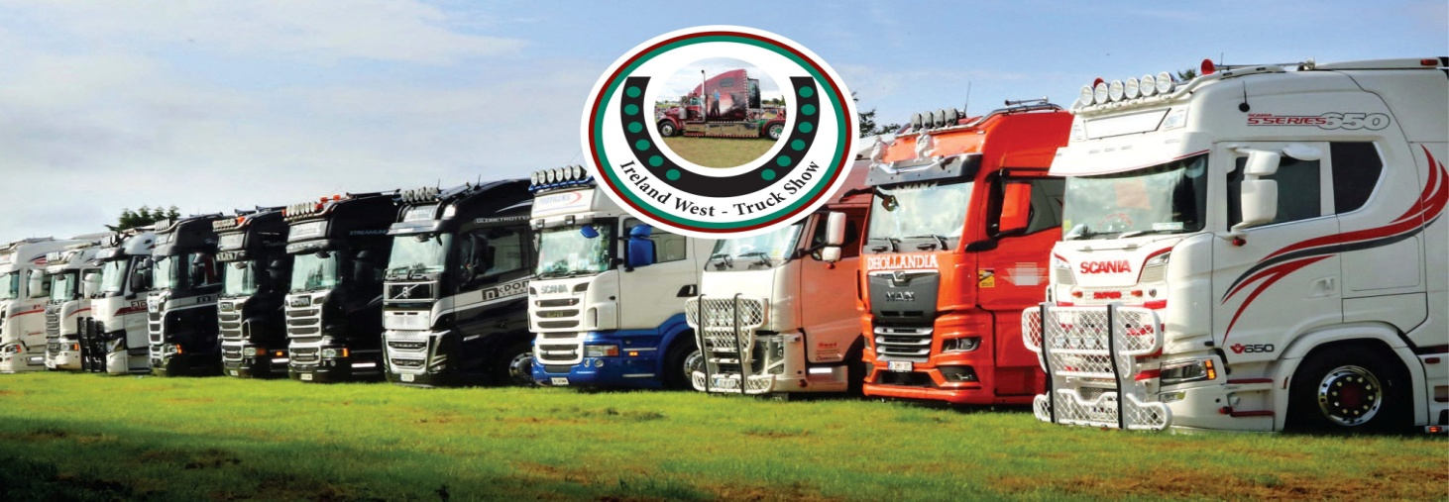
18th August 24 in Headford mart, Headford Co Galway
Best:- Scania, Volvo, Merc, Renault, Hine, Iveco, Man, Daf, Rigid, Fleet, best small commercial Recovery Vehicle, Working truck over 5 years, & Truck of the show,
Entry fee:- € 30.00 per truck / fleet of 3 or more € 90.00
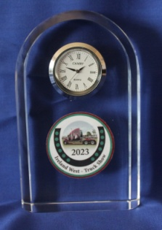
Winning prize
Free:- Meal voucher & show plaque to all drivers who register
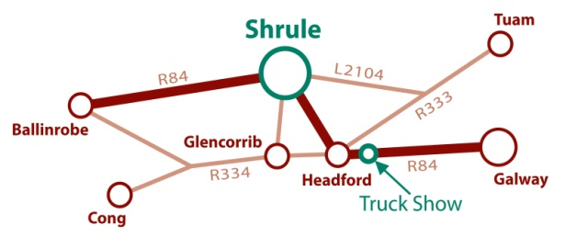
For more information visit :- www.irelandwest-truckshow.com
Face book:- Michael Craddock ( irelandwest-truckshow )
Mobile 087 2654865

As you drive on the Galway /Headford road ( R 84 ) The truck show site is located to the right just after you pass Joyces Hardware store.
Drivers who come via Shrule MUST go up through the town of Headford and turn left at the traffic lights Drivers are not to try and entre the site by turning in by the side of the old bank of Ireland. This laneway will be closed.

